**Final Year Project Report**



**Smart Dustbin Using IoT**

**Bachelor of Science**

in Computer Science

**Submitted by**

Muhammad Affan Ali EP1650035

Muhammad Raza Rizvi EP1650051

Muhammad Faraz Ahmed EP1650039

Supervised by

**DR. M. SADIQ ALI KHAN**

**DEPARTMENT OF COMPUTER SCIENCE**

**UNIVERSITY OF KARACHI**

**2020**

Abstract

We are living in a world that is in a state of constant up-gradation, but there is one ubiquitous problem that we have not been able to deal with, the problem that is impeding our advancement to a hygienic, clean and healthy society, is garbage. Many times, in our city we see that the garbage bins or dustbins placed at public places are overloaded. It creates unhygienic conditions for people as well as ugliness to that place leaving bad smell which may lead to sanitary issues and disease. This kind of situation is neither good for our environment nor for our advancement. This problem leads to huge number of diseases as large number of insects and mosquitoes breed on the waste accumulated in this garbage. In recent years, waste has been a problem to many environments whereas the use of different strategies has been put in place to solve the problem. The impacts of these wastes on the economy cannot be ignored and managing them has become a major problem.

This report describes that the Smart Dustbin is a very innovative system which will help to keep the cities clean. Hence, we developed a project to control the overfilling of the dustbin by making the dustbin smart enough to notify itself for its cleaning. In this project the Smart Dustbin management system is built on the microcontroller-based system having ultrasonic sensors on dustbins that will show the current status of garbage on the LCD screen as well as on the mobile. The main aim of this project is to reduce human resources and efforts along with the enhancement of a smart city vision. Furthermore, it is expected to contribute to improving the efficiency of the solid waste disposal management.

# CERTIFICATE OF COMPLETION

**This is to certify that the following students**

Muhammad Affan Ali EP 1650035

Muhammad Raza Rizvi EP 1650051

Muhammad Faraz Ahmed EP 1650039

**Have successfully completed their final year project named**

**Smart Dustbin Using IoT**

**In the partial fulfillment of the Degree of Bachelor of Science in Computer Science**

Signature & Seal of Supervisor

Name: Muhammad Affan Ali

Muhammad Raza Rizvi

Muhammad Faraz Ahmed

Department: UBIT (Computer Science)

Email: affanali714@gmail.com

razarizvi447@gmail.com

faraz_ahmed22@outlook.com

Mobile No. +923162121466

+923039084899

+923003578740

Date: 3rd January 2020

# ACKNOWLEDGEMENT

We first extremely thank ALL MIGHTY ALLAH who make us able to do work on this project. First of all, every journey is starting with a single step this is an opportunity for any undergraduate student who reach at this final step and make an able to convert his idea into reality however as we are computer science students reach at this final step to make such a product which create impact on this fast-growing market. It’s not a single day making product but a days and night full of hardworking searching thinking coding designing and that’s all. To covert a non-existing thing and idea into reality is such a big opportunity for us we learn many experiences and face many problems throughout the journey but we can say that we can do it and everything is possible if you are motivated or dedicated.

We are extremely appreciative to all the faculty members of department of computer science UBIT university of computer who make us able that we are able to reach at this stage to make a final year project although it’s a long journey in which we face some hurdles but Alhamdulillah passed all the exams and now we are at this stage that we present our final year project report.

We are very thankful to our teachers who teach us and guide us what to do and how to do. It’s not a single person working but it’s a teamwork or an extreme cooperation of our teachers who cooperate with us or help us to do the things better or create such type of product which does not exist it before which create impact on market and use such technologies which is latest and the future world is also depend on it. At the End we also congratulate and present heartily thankful wishes to our mentors who help us and cooperate with us.

Table of Contents

Abstract ii

CERTIFICATE OF COMPLETION iii

ACKNOWLEDGEMENT v

List of Figures viii

List of Tables ix

List of Keywords 1

1 Introduction 1

1.1 Motivation 1

1.2 Aim and Objective 2

1.3 Outline of the Project 3

1.3.1 Introduction 3

1.3.2 The First Look 3

1.3.3 Live Status of Dustbin 4

1.3.4 Graphical Representation of Data 4

1.3.5 Ultrasonic Sensors 4

1.3.6 Project Summary 4

2 Introduction of Internet of Things 6

2.1 Why Internet of Things? 6

2.2 Why we choose AI in our Project? 6

2.3 Advantages of Internet of Things 7

3 NodeMCU and Sensor Works 9

3.1 Materials Needed 10

3.2 Hardware Requirement 10

3.3 Software Requirement 11

3.4 Installing Drivers and Libraries Necessary 11

4 Designing and Operating Environments 12

4.1 Design and Implementation Constraints 12

4.2 Assumptions and Dependencies 17

4.3 Database 17

5 Output and Comparison of the Project 18

5.1 Comparison with Available Market Products 18

5.2 Needs for Improvement in Waste Management Sector 18

5.3 Project Scheduling and Management 20

5.4 Output of the Project 22

5.5 Project Costing 27

6 Conclusion and Future Enhancement 28

6.1 Scalability 28

6.2 Self-Modeled Methods 29

References 30

Appendix – A: User Manual 31

List of Figures

**Figure 3.1:** Assumtion output …………………….….…….…....……………....09

**Figure 4.1:** Use Case Diagram…………………….….…….…....……………....13

**Figure 4.2:** Class Diagram……………………….………….…………….….….14

**Figure 4.3:** Entity Relationship Diagram………….….……………….................15

**Figure 4.4:** Circuit Diagram……………………………………...........................16

**Figure 5.1:** Model Images…………………….….…….…....……….……..........19

**Figure 5.2:** Gantt Chart……………………………………...................................20

**Figure 5.3:** Network Diagram………………………………….............................21

**Figure 5.4.1:** Circuit Diagram…………………………………….........................22

**Figure 5.4.2:** Model Images…………………….….…….…....……….……........23

**Figure 5.5.1:** Gantt Chart…………………………………….................................24

**Figure 5.6.1:** output of Application...……………………………......................... .25

**Figure 5.6.1:** output of Statical data...……………………………......................... .26

List of Tables

**Table 2.1:** Table of List of the Equipment…………….……...…….…...…...….17

# List of Keywords

IoT – Internet of Things

US – Ultrasonic Sensor

CDB – Cloud Database

JSX – JavaScript XML

CSS – Cascading Style Sheets

JSON – JavaScript Object Notation

# Introduction

The quantity of waste generated and their potential impacts depend on multifarious factors, including the level of industrial development, the way in which wastes are managed, the existing state of the local environment and the capacity of the receiving media. Nowadays, cities with developing economies experience exhausted waste collection services, inadequately managed and uncontrolled dumpsites and the problems are worsening. The key issue of an inadequate waste management is that the garbage bin at public places gets overflowed well in advance before the commencement of the next cleaning process. Hence, we need such a system that can deracinate or at least minimize this problem to some extent. With the advancement in technology it is high time that we use technology for waste management systems. The Smart Dustbin is a singular solution to the specific and peculiar problems in waste management sector.

## Motivation

In most of the business world today, not a day passes without advancement in Internet of Things (IoT) as it has become mainstream. Few industry experts are of the opinion that would be closely connected to popular culture thus driving the people to have improbable expectations and unrealistic fears about how it will alter the life and workplace in general.

Smart Dustbin based on IoT is one of the core component of modern age hype Smart City. There are countless Smart IoT based Solutions for waste management systems which are being implemented throughout the globe, in the developed and first world countries to be specific. However, Waste management is also a great problem in poor developing countries as waste is scattered all over roads due to improper methods of collection and dumping thus polluting the environment. Due to lot of factors including socio-economic and cultural drawbacks existing smart solutions are not compatible in developing countries like Pakistan, as there exist basic problems regarding the primary task of waste management like proper disposal, collection, sorting, recycling etc.

The world is now move forward without and withholding any barrier the different Enterprise level industry and software developer communities should add their work in this global cause however many losses also occurred to achieve this goal but work is continuous and we are move forward to achieve our goal. Internet of Things is now spread in this world and each and every aspect of human life should be cover in this domain we can say that IoT play an important role in human life.

As a final year student to add a valuable feature in our academic period we think that we can do some different and choose such type of project which could help the people in our society. Everyone should know that garbage collection is a big problem so to sort out this problem we choose IoT with their help of technology solutions we make such type of project which is helpful for the government or waste management organization to help out this problem so it’s a big motivation for us.

## Aim and Objective

Smart Dustbin is an idea where we can control lots of problems which disturbs the society in pollution and diseases. The waste management has to be done instantly else it leads to irregular management which will have adverse effect on nature. The Smart Dustbin is compatible mainly with concept of smart cities. The main objectives of our proposed system are as follows:

1. Monitoring the garbage bin.

2. Providing a smart technology for waste management system.

3. Avoiding human intervention.

4. Reducing human time and effort.

5. Plot the graph of our garbage.

6. Resulting in healthy and waste ridden environment.

To overcome the garbage problem, we use such an emerging technology in which less of human’s resource is used and more part is done with the help of smart system. The system is mainly built for smart cities to present the innovative ideas for the future enhancement. The main objective is to find out the garbage bin where a huge amount of garbage is filled and to reach out this info to responsible organizations to reach on these places and take the garbage from Dustbin is to keep cities, streets and roads clean.

## Outline of the Project

The project is basically for the government organization who look after the work of cities cleanliness lots of NGOs or non-governmental organizations also work for this cause as a volunteer but this issue is remain the same we want to developed such type of product which help out these organizations to at least minimize this problem our basic goal is to minimize the garbage problem in the city and informed the concerned organization to look out these problem however this is a local body organization responsibility. The garbage addition is a cyclic process no one can say that we can stop it because where living beings is lived there is necessity needs of different people in any form. The proposed project is fully functional not for the general people but the waste management organization to reach out at the areas where citizens put their home garbage in dustbin and organization is responsible to took this dirty garbage with the help of the technology. This is a long process; we easily define our project in the following paragraph to easily understand our project or see what our project can do for the general people.

### Introduction

The proposed name of our final year project is ‘Smart Dustbin using IoT’ in this project we use the most emerging technology called Internet of Things however everyone should better know that IoT is a broad field there is lots of another field under this field although we use the sensors to do our project. In front end GUI we use react the JavaScript framework and connect it with firebase at the back end as database.

### The First Look

In first page of our project we use the slider images with the help of our users to check the application if you are use our project you can check the level of Dustbin and Statically Data from anywhere in the world.

### Live Status of Dustbin

You can check the live status of dustbin from anywhere and every time. There are three type of possibilities

1. Empty
2. Half
3. Full

If the color shows the Green color this means that the Dustbin is Empty. And if the color shows the Green and Yellow colors this means that the Dustbin is Half. And if the color shows the Green, Yellow and Red colors this means that the Dustbin is Full.

### Graphical Representation of Data

In our app we are showing a data in graphical form so there are many graphs in our project.

1. Vertical Bar Graph
2. Marks series Graph
3. Line Series Graph
4. Box plot Graph.
5. Pie Chart Graph

### Ultrasonic Sensors

Ultrasonic sensor is a device used to measure the distance of an object by using sound waves. It can measure the distance by sending the sound waves at a specific frequency and listen the sound waves to bounce back. By using the elapsed time between the sound wave generated and sound wave bounce back, the sensor can be able to calculate the distance between the sensor and the object. The waste level is determined by measuring the distance from the top of the trashcan to the waste. It can provide measurement from 2cm to 400cm with 3mm accuracy, which adequate for typical trashcans.

### Project Summary

Its presents this project is based on Internet of Things but in future there are more advancements is present in such type of projects as the world is move forward and lots of applications and webs are built day by day lots of people work together communities also help out to find the best possible solution however this type of projects is also build on using AI and other Augmented reality type emerging technology there are lots of way in which we can work on future to improve the accuracy the more mindsets work the more new ideas are generated.

# Introduction of Internet of Things

In today's world, technology is growing very fast, and we are getting in touch with different new technologies day by day.

Here, one of the booming technologies of computer science is Internet of Things which is ready to create a new revolution in the world by taking all the things in the world and connecting them to the internet. The Internet of Things is now all around us. It is currently working with a variety of subfields, ranging from general to specific, such as Internet of Digital (IoD), Internet of Things (IoT), and Internet of Humans (IoH) etc.

IoT is one of the fascinating and universal fields of Computer science which has a great scope in future. IoT holds a tendency to cause a sensor to work with an Arduino.

## Why Internet of Things?

Before Learning about Internet of Things, we should know that what is the importance of IoT and why should we learn it. Following are some main reasons to learn about IoT:

* IoT means that everything from household appliances, to construction equipment, to vehicles and buildings will transmit data and communicate with other objects or people.
* IoT creates massive amounts of data that can be analyzed and used to make better decisions. This data can be analyzed and used in real time.
* The more communication among machines, the more connected they are and Data won’t be siloed into one particular industry. It will be used across businesses and industries, fueling innovation.

IoT opens a path for other new technologies, new devices, and new opportunities.

## Why we choose IoT in our Project?

There are lots of reason that we work on Internet of Things in our project but the main reason it that there is no such type of App should make on IoT there are projects which also classify garbage from different types of garbage bin but work on using different technologies like Artificial Intelligence Machine Learning, Deep Learning base etc. our struggle is to unleash our potential to work on Artificial intelligence we can see that there are also lots of different fields in Internet of Things which provide best results in run time but we also see that there are huge amount of data is used in our project as it is our final year project it is also showcase our core strength in job market as it is teamwork. In our project we can work on Arduino NodeMCU, Servo and Ultrasonic sensors with the help of these emerging technologies we try our best efforts to give good solution and make such type of product which cannot be make before.

## Advantages of Internet of Things

Following are some main advantages of Internet of Things:

* **Access information:** You can easily access data and information that is sitting far from your location, in real time. This is possible because of the network of devices; a person can access any information sitting from any part of the globe.
* **Communication:** As mentioned in the point above, communication between electronic devices is made easier because of IoT. This helps people in daily tasks. Transferring data packets over a connected network save time and money.
* **Automation:** Automation is the need of the hour to manage everyday tasks without human intervention. Automating tasks in a business helps boost the quality of services and reduce the level of human intervention.
* **Useful in Monitoring:** One of the most apparent advantages of IoT is monitoring. It provides an advantage of knowing things in advance. With this, the exact quantity of supplies, water distribution and consumption, intelligent energy management, and security distribution gets collected easily.
* **Gathers Useful Data:** The more significant the information, the easier it is to make the right decision. The amount of information taken from devices that communicate with each other will aid the consumer to know what is wrong with the device.
* **Efficient and Saves Time:** The machine-to-machine interaction provides better time response and overall device operation performance. Since the IoT system produces accurate results in an instant, it enables people to do other creative jobs. Its fast-paced function saves a lot of valuable time.

# NodeMCU and Sensor Works

To start with you will first have to enter the height of the dustbin. This will help us generate the percentage of trash in the trashcan. We then have two criteria’s which needs to be satisfied to show that the particular bin needs to be emptied:

1. The amount of trash, in other words let's say if your bin is half full you don't really need to empty it. Our thresh, or maximum amount that we permit of trash, is 75% of the bin. (You could alter the thresh according to your preference).
2. 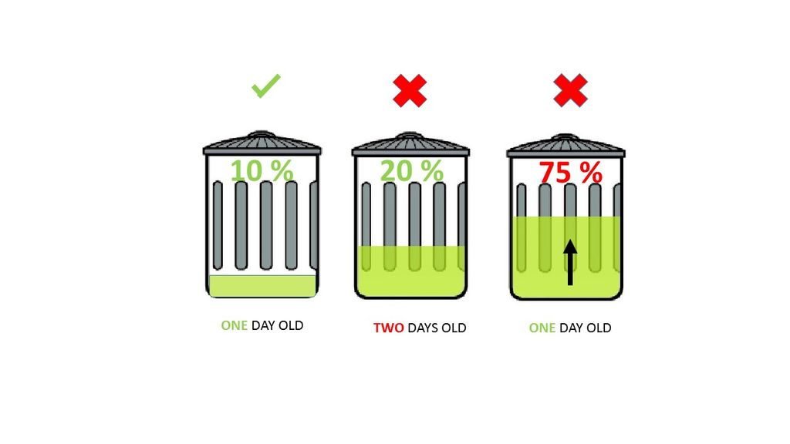If supposing a particular trashcan fills up 20% and then for a week doesn't change, it comes into our second criteria, time. With time even the little amount will start rotting leading to a smelly surrounding. To avoid that our tolerance level is 2 days, so if a trashcan is less than 75% but it is two days old it then will also need to be emptied.

Fig:3.1 Assumption output

With these criteria’s in mind let's understand the technical part:

* An ultrasonic sensor (A.K.A a distance sensor) will be placed on the interior side of the lid, the one facing the solid waste. As trash increases, the distance between the ultrasonic and the trash decreases. This live data will be sent to our micro-controller.
* Our micro- controller then processes the data and through the help of WIFI sends it to an app.
* What the app does it visually represents the amount of trash in the bin with a small animation.

This process will indicate all the bins which require attention, leading the user to take the most effective route.

## Materials Needed

* 1. Arduino NodeMCU ESP8266
  2. Ultrasonic Sensors
  3. Wires
  4. Battery
  5. Plastic container
  6. Dustbin etc.

## Hardware Requirement

* [**2 x AA Batteries**](http://www.gearbest.com/led-strips/pp_432122.html)  These batteries will power the Arduino board.
* [**Plastic Container**](http://www.gearbest.com/storage-boxes-bins/pp_588584.html)  I found an old plastic container in which all the components could fit. The box is important as you can easily access the components and it's waterproof.
* **Ultrasonic Sensor** An ultrasonic sensor measures distance. It will be attached to the lid indicating the quantity of trash. Our system's key component.
* **Arduino NodeMCU 8266** The center piece is one of Arduino's latest micro-controller, which simplifies the task of connecting to the Internet using prebuilt libraries that can be downloaded.
* [**White Spray Paint**](https://www.amazon.co.uk/d/Adhesive-Sprays/Plasti-kote-3100SE-400ml-Super-Spray/B001GU8B18/ref=sr_1_1?ie=UTF8&qid=1498380652&sr=8-1&keywords=white+spray+paint) Turn your regular box into a more professional product.
* **Jumper Wires** To connect the NodeMCU with sensors and servo.

**TOOLS:**

* [Electric Drill](http://www.gearbest.com/other-tools/pp_414554.html)
* Hot Glue Gun

## Software Requirement

* [Arduino IDE](https://www.arduino.cc/en/main/software)
* [Blynk](http://www.blynk.cc/) an android app that allows communication with Wi-Fi compatible micro-controllers

## Installing Drivers and Libraries Necessary

To be able to program the Arduino ESP8266, you need to first install the drivers. To check if you already have them installed open the Arduino IDE, click on tools then boards and look if either Arduino ESP8266.

# Designing and Operating Environments

This chapter include Designing and Operating Environments of our project so the Operating Environments for the Smart Dustbin Monitoring System is as listed below.

1. Distributed Database

2. Client/Server System

3. Operating System: Windows/Android for mobile

4. Database: Firebase Database

5. Platform: React frontend and C++ language (for sensors)

## Design and Implementation Constraints

1. The global schema, fragmentation schema, and allocation schema.
2. SQL commands for above queries/applications
3. How the response for application 1 and 2 will be generated. Assuming these are global queries. Explain how various fragments will be combined to do so.
4. Implement the database at least using a centralized database management system.
5. Unified Modeling Diagrams

**Unified Modeling Diagram**

**Use** **Case Diagram**

A use case diagram is usually simple. It does not show the detail of the use cases: It only summarizes some of the relationships between use cases, actors, and systems. It does not show the order in which steps are performed to achieve the goals of each use case. As said, a use case diagram should be simple and contains only a few shapes. If yours contain more than 20 use cases, you are probably mis-using use case diagram.

The figure below shows the UML diagram hierarchy and the positioning of UML Use Case Diagram. As you can see, use case diagrams belong to the family of behavioral diagrams.

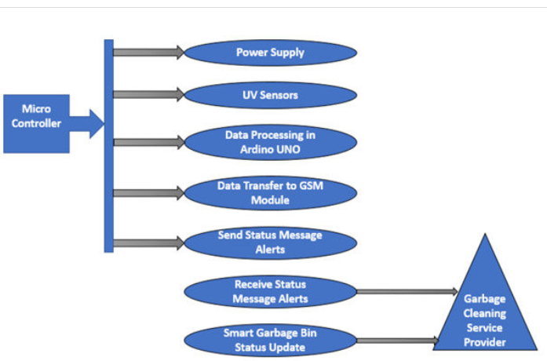

**Figure 4.1:** Use Case Diagram

Class Diagram

In software engineering, a class diagram in the UML is a type of static structure diagram that describes the structure of a system by showing the system's classes, their attributes, operations (or methods), and the relationships among objects.

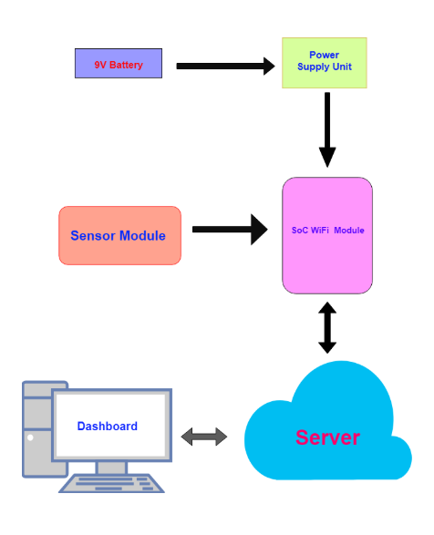

**Figure 4.2:** Class Diagram

**Entity Relationship Diagram**

An **Entity Relationship Diagram (ERD),** also known as an entity relationship model, is a graphical representation of an information system that depicts the relationships among people, objects, places, concepts or events within that system.

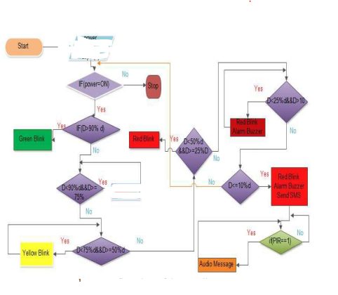 **Figure 4.3:** Entity Relationship Diagram

**Circuit Diagram**

A **Circuit diagrams (CD)** of the system below there is a circuit diagram of the overall system which was designed by using proteus software.

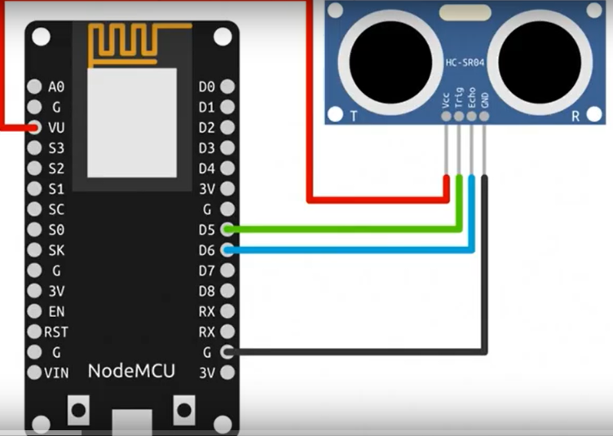

**Figure 4.4:** Circuit Diagram

## Assumptions and Dependencies

The report assumes that none of the constituent system components will be implemented as embedded applications. The implication is that the target hardware will provide a capacity for standalone program/application deployment and not require customized embedded firmware to be written. It is further assumed that tablet PCs of sufficient processing capability and battery life will be utilized. The surface computers employed by the system should facilitate being utilized/left on for extended periods (sufficient for daily use) and that they are programmable in the same fashion as x86 architecture computers. Finally, it is further assumed that the deployment environment is capable of supporting an IEEE 802.11 wireless network for system communication.

## Database:

We are use cloud firestore database. It is cloud base Database. In cloud firestore we create Database tables are describe below:

**Table of List of the Equipment**

|  |  |  |  |
| --- | --- | --- | --- |
| Serial No. | Item | Quantity | Cost |
| 1. | NodeMCU | 2 | 900/- |
| 2. | Ultrasonic Sensors | 2 | 350/- |
| 3. | Servo | 1 | 380/- |
| 4. | Solar Panel | 1 | 1150/- |
| 5. | Jumper Wires | 16 | 80/- |
| 6. | Garbage Bin | 1 | 160/- |
| 7. | Thread | 1 | 20/- |

**Table 4.1:** Table of List of the Equipment

# Output and Comparison of the Project

This chapter describes the output of our project and comparison with available market product and also describes the needs for improvement in waste management sector. The project output is to we have a system which gives a real time indicator of the garbage level in a trashcan at any given time. Using that data, we can then optimize waste collection routes and ultimately reduce fuel consumption. It allows trash collectors to plan their daily/weekly pick up schedule. This system makes our environment clean and ensure hygienic surrounding. In real sense, it is great help for society cleanliness. Therefore, it is more efficient and also cost-effective system.

## Comparison with Available Market Products

Waste management is all the activities and actions required to manage waste from its inception to its final disposal. This includes collection, transportation, treatment and disposal of waste together with monitoring and regulation. Waste collection methods vary widely among different countries and regions. Domestic waste collection services are often provided by local government authorities.

Curbside collection is the most common method of disposal in most countries, in which waste is collected at regular intervals by specialized trucks. Waste collected is then transported to an appropriate disposal area.

Nowadays, cities with developing economies experience exhausted waste collection services, inadequately managed and uncontrolled dumpsites and the problems are worsening. Waste collection method in such countries is an on-going challenge and many struggles due to weak institutions and rapid urbanization.

## Needs for Improvement in Waste Management Sector

Efficient and energy-saving waste management, reducing CO2, air pollution and vehicle exhaust emissions—these are just a few examples for the demands of future cities. In views of that, the efficient use and responsible handling of resources become more important.

Effectively managing waste is important in developed countries. Waste management may swallow up to 50% of a city’s budget, but only serve a small part of the population.

Sometimes, up to 60% of waste is not being collected, it is often simply burned by the roadside. It can pollute drinking water; it can spread disease to people living nearby.

Even with great route optimization, the worker must still physically go to the dustbin to check waste levels. Because of this, trucks often visit containers that do not need emptying, which wastes both time and fuel.

Waste management prevents harm to human health and the environment by reducing the volume and hazardous character of residential and industrial waste.

**Model Images: (Final Product)**

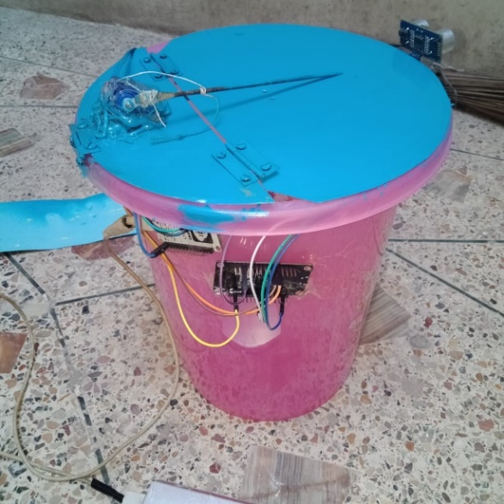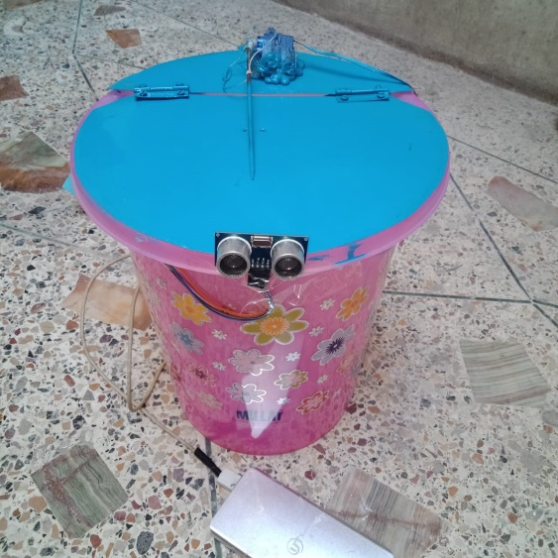

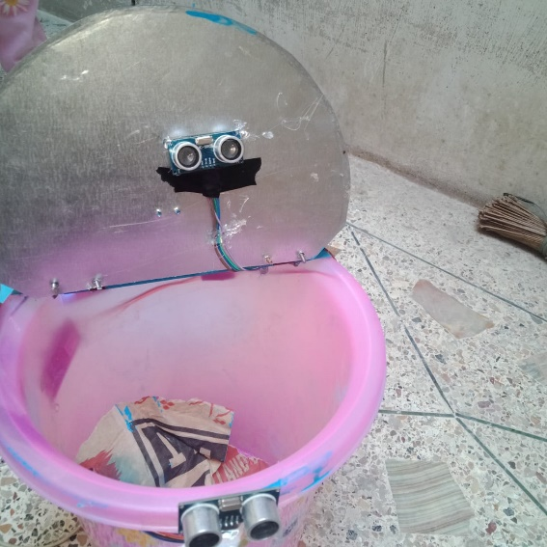

**Figure 5.5** Model Images

## Project Scheduling and Management

**Gant Chartt**

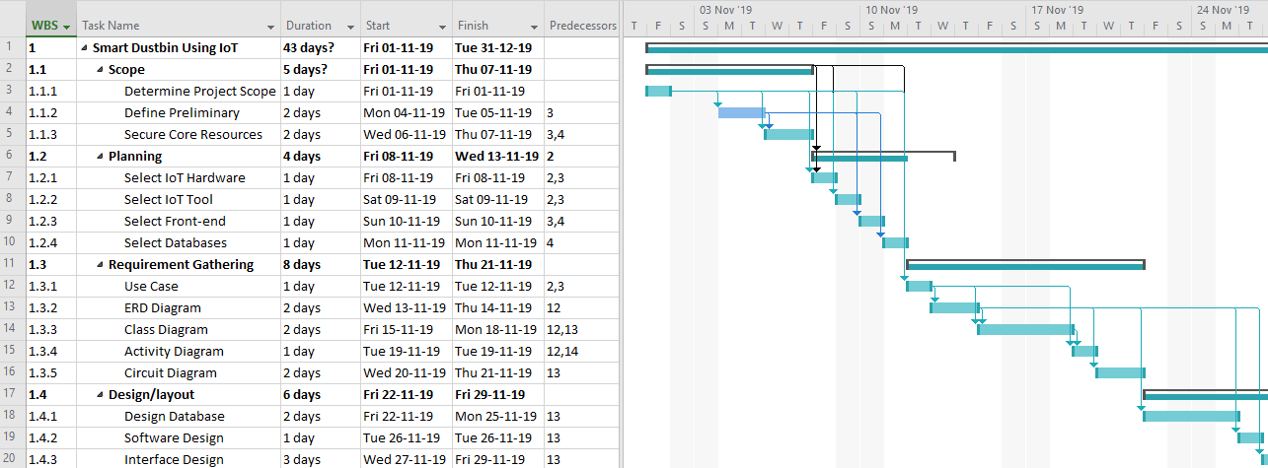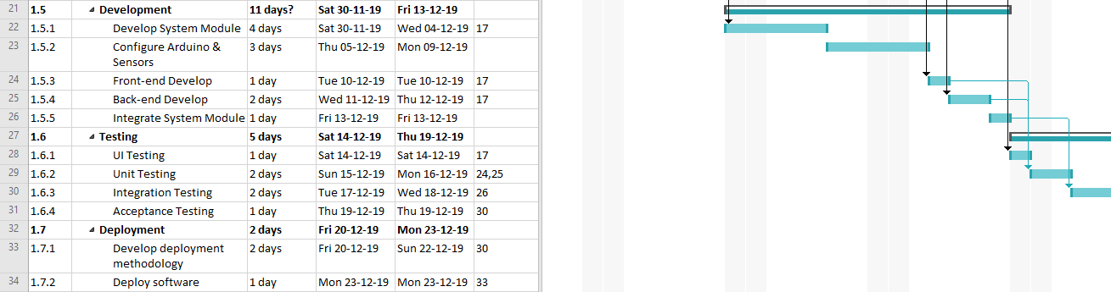

**Figure 5. 2 : Gannt Chartt**

**Network Diagram**

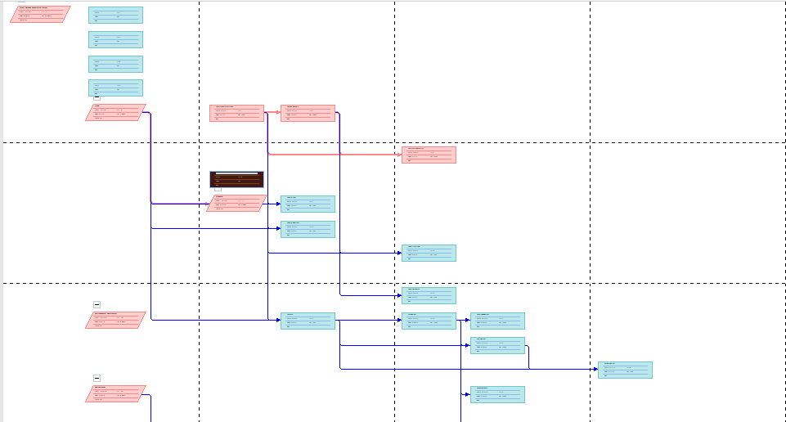

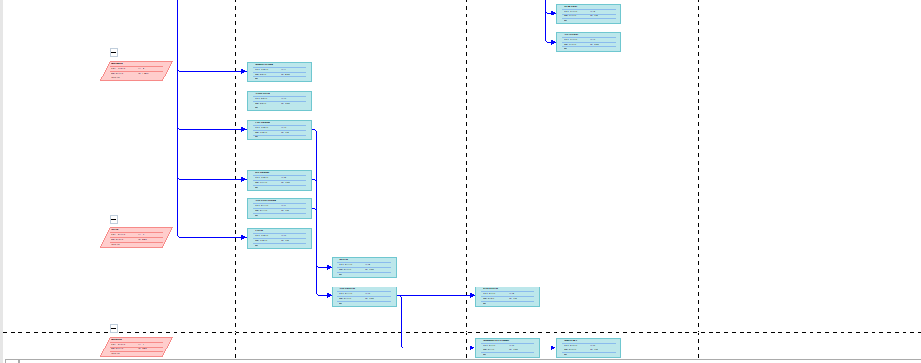

**Figure 5. 3 :**  Network Diagram

## Output of the Project

In Desktop view, you can see output as given below:

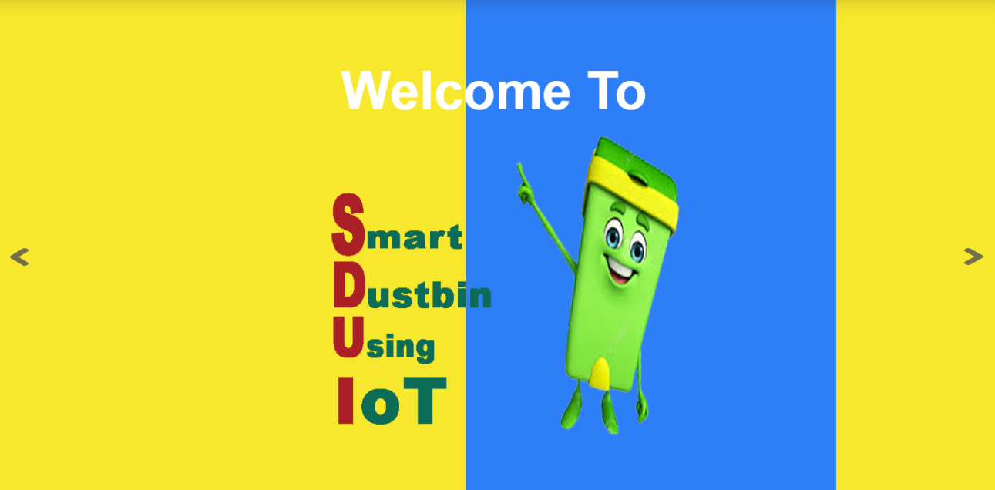

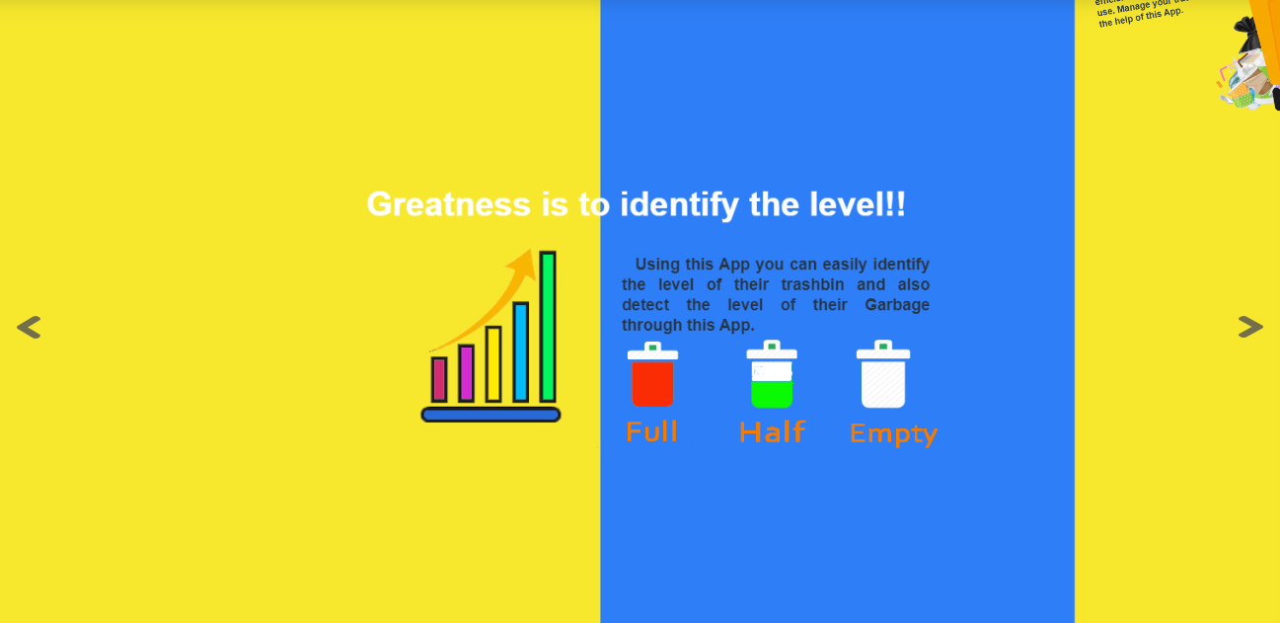

Fig: 5.4.1 Desktop veiw

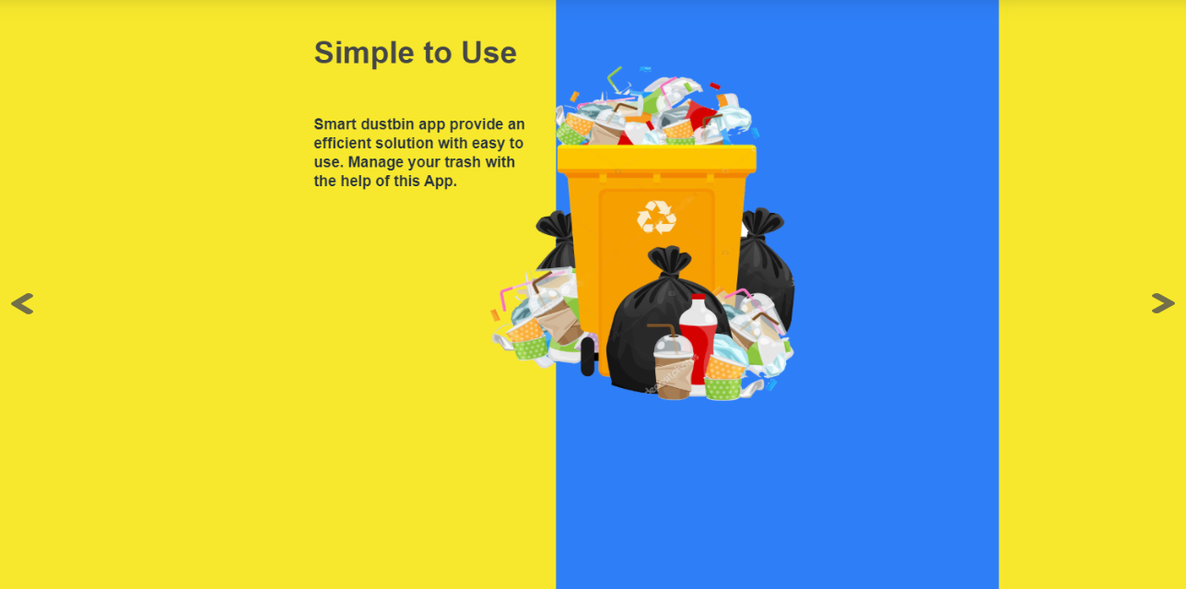

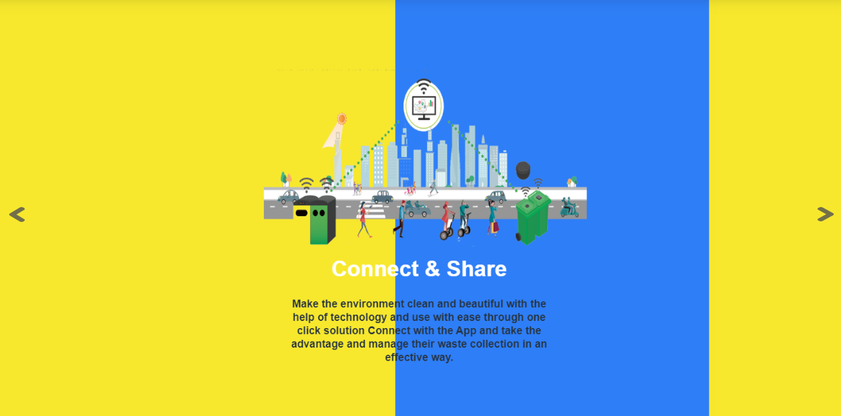

Fig: 5.4.2 Desktop veiw

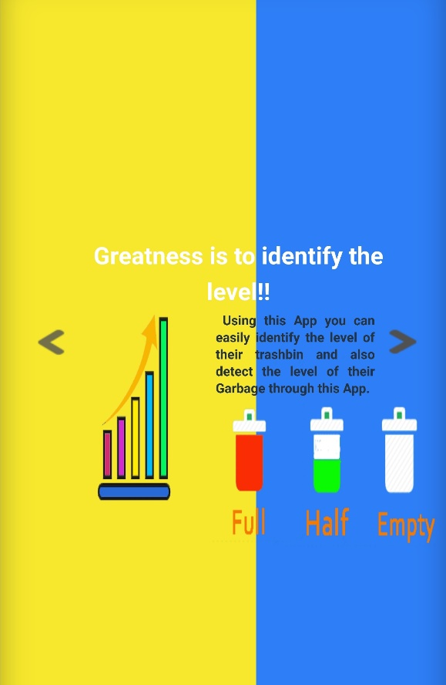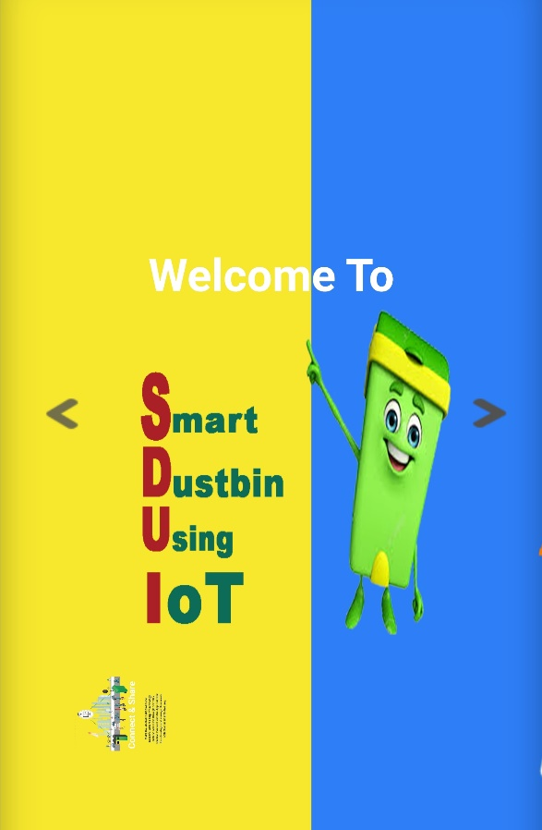In Mobile view, you can see output as given below:

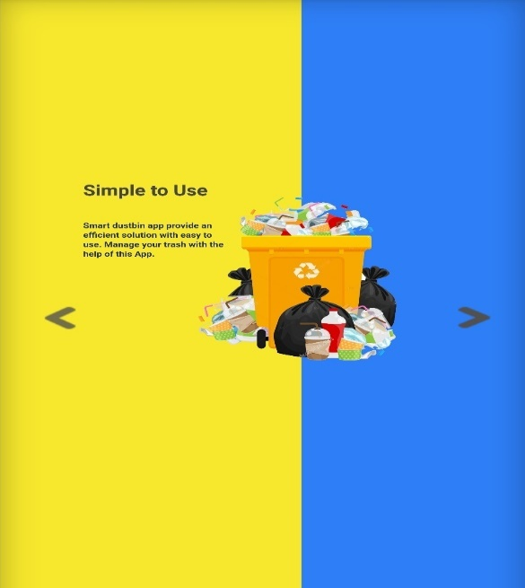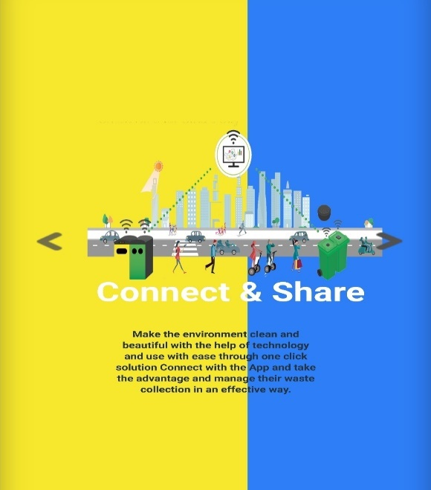

Fig: 5.5.1 Mobile View

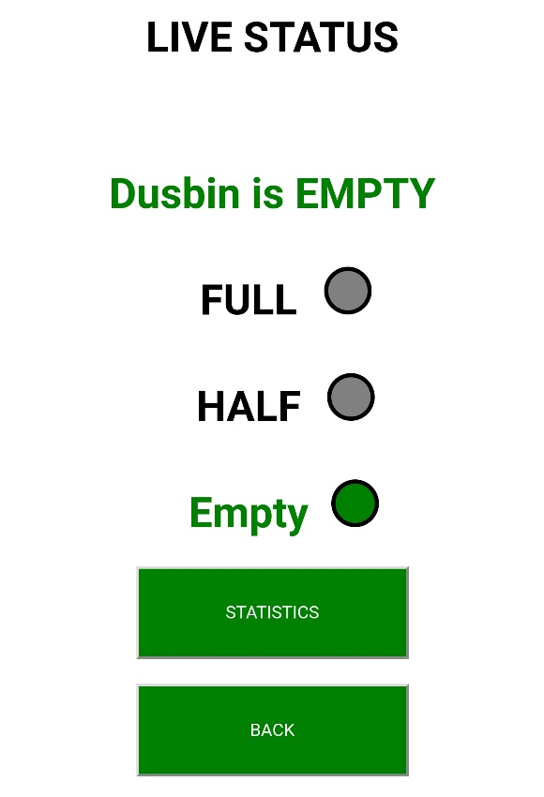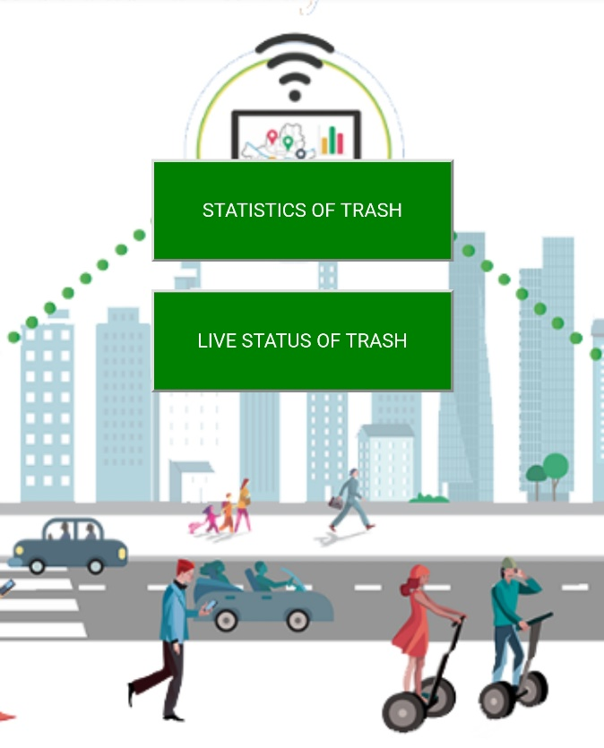

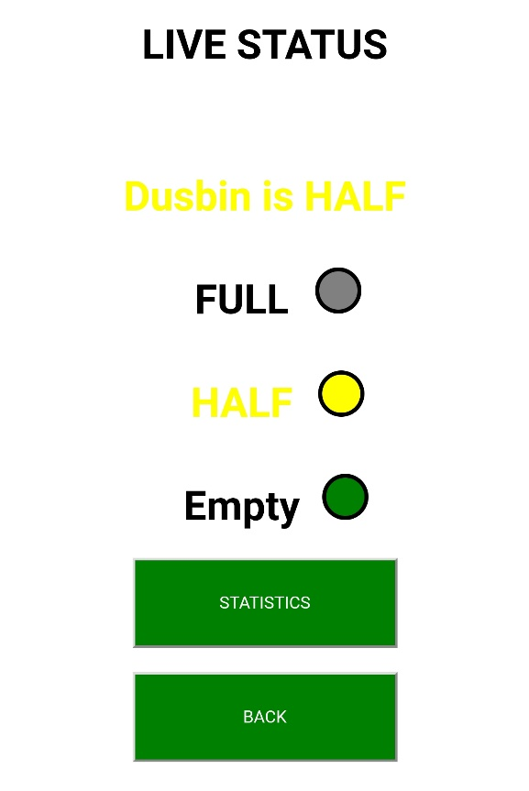

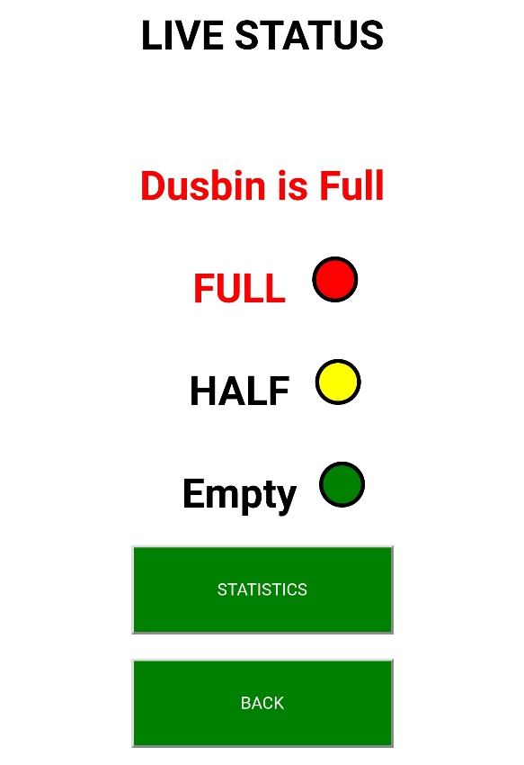

Fig: 5.6.1 output of Application

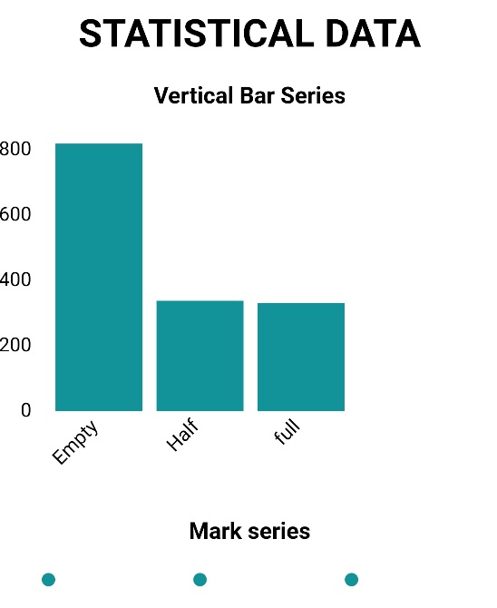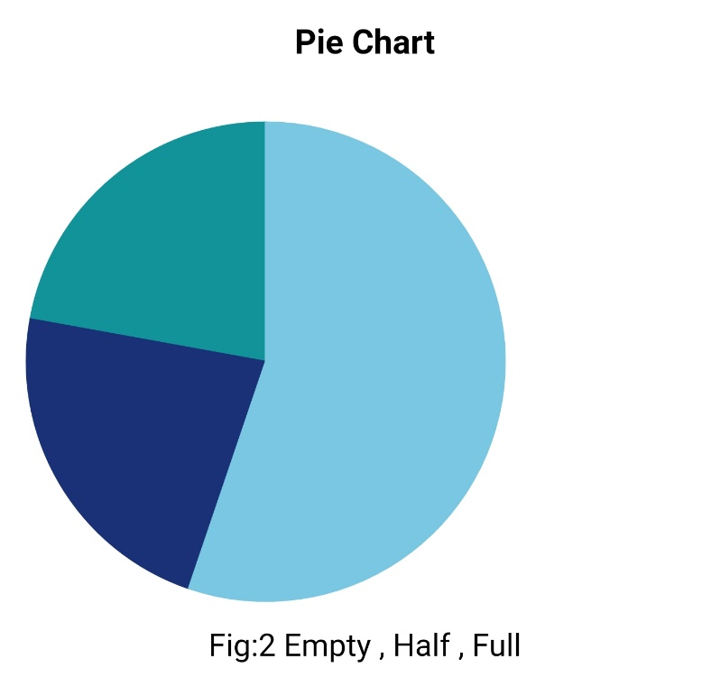

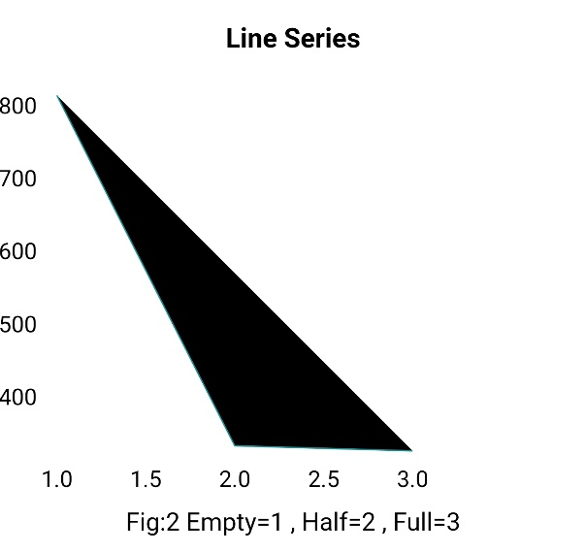

**Fig: 5.6.2 output of statistical data**

**Note**: Maximam scale of Graph may be 17,208 because Every every 5 sec delay the date I will send to server and All data delete after 24 min i.e 12 5’s in 1 second and 12 X 60X24 = 17,208 in 24 hpurs

## Project Costing

* Requirement gathering --------------------------------------Rs: 12,000
* Designing costing-------------------------------------------- Rs: 14,000
* Development cost-------------------------------------------- Rs: 25,000
* IoT Hardware------------------------------------------------- Rs: 10,000
* Database designing------------------------------------------- Rs: 8,000
* Testing---------------------------------------------------------- Rs: 12,000
* Deployment---------------------------------------------------- Rs:15,000
* Report costing------------------------------------------------- Rs: 1000
* Other costing--------------------------------------------------- Rs: 5000

**Total Project Costing** Rs:100,000

# Conclusion and Future Enhancement

Having seen the potential in this technology there are countless huge firms sponsoring and investing in Internet of Things and its applications. Like any other technology this technology is also not perfect. There are numerous implications and challenges faced by this growing technology but what we hope to achieve in an ideal case is perfection but reality is harsh so we seek what is closest to perfection. Internet of Things offers us exactly what we seek in reality.

The Smart Dustbin integrated with IoT provides a clear and understandable proof of concept system, demonstrating the architecture of IoT technology and its postulates that lead to fraud less, immutable and transparencies of different pictures that the user is upload on this system. The system provides authentications as well as provides a clear and understandable picture of the information that the user is share with comprehensive document reviewing and data sharing.

## Scalability

The scalability is very crucial in every project that is to be designed and our project is not very different. The project we have designed targets only a specific part of a government organizations. This project that we took up can be expanded to whole IoT including the other significant entities involved in the chain. Not just the system this project could be used in other applications when integrated with AI (Artificial Intelligence) and other technologies.

Another aspect that comes with scalability is the issue of developing a system that is ideal. We have implemented the management of waste in real time using smart dustbin to check the fill level of dustbin to check if it is full or not. This is quite unacceptable throughput for most business applications. We have implemented sensor-based system because it is a default consensus system that is used in react or JavaScript framework used but there are other algorithms that are better. These systems also have their drawbacks as they say there is no another picture added. This issue is rather known as the Scalability Trilemma where one has to compromise on at least one of the three most crucial concepts i.e. fast, secure and decentralized.

## Self-Modeled Methods

Plus, we can add Self Modeled Methods to ensure that the system is efficient. To reduce the risk of unknown or unspecified things on the system we can self-model documents like for example sensor-based system so that it can self-execute detection. This would lead to faster, efficient and ensure to the concerned departments and eliminate the ambiguities in the process.

# References

[1] United Nations Environmental Programme (2013),"Guidelines for National Waste Management Strategies Moving from Challenges to Opportunities"

[2] Yusof, N.M., Jidin, A.Z., Rahim, M.I, “Smart garbage monitoring system for waste management”,

MATEC Web of Conferences Engineering Technology International Conference, vol. 97, EDP

Sciences (2017), p.01098.

[3] Issac, R., Akshai, M, “SVASTHA: an effective solid waste management system for Thiruvalla

Municipality in Android OS”, Global Humanitarian Technology Conference: South Asia Satellite,

GHTC-SAS, Trivandrum, India, IEEE (2013), pp. 254–259.

[4] Rajkamal, R., Anitha, V., Nayaki, P.G., Ramya, K., Kayalvizhi, E., “A novel approach for waste segregation at source level for effective generation of electricity—GREENBIN.”, International Conference on Science Engineering and Management Research, ICSEMR, Chennai, India, IEEE (2014),

pp. 1–4.

[5] Kumar, N.S., Vuayalakshmi, B., Prarthana, R.J., Shankar, A., “IOT based smart garbage alert system

using Arduino UNO.”, Region 10 Conference, TENCON, Singapore, IEEE (2016), pp. 1028– 1034.

[6] Thakker, S., Narayanamoorthi, R., “Smart and wireless waste management”, International Conference on Innovations in Information, Embedded and Communication Systems, ICIIECS, Coimbatore, India,

IEEE (2015), pp. 1–4

# Appendix – A: User Manual

This is important as it will help the users to learn how to use the product correctly. An operation manual template will contain relevant guidelines.

This is the first page of our product where you can see the welcome page.



Click here and navigate to next slide



And this is also the slider page so you can see the other content by clicking on the left or right side.  

Click here and navigate to another slide



Click here and navigate to another slide



Click here and navigate to another slide

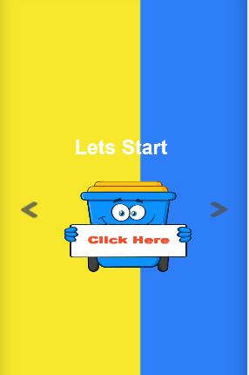

Click here and navigate to Home Page

Now this is the main page pf the project where you can see two button and one of the buttons shows the statistics of trash and the other button is to show the live status of the trashcan.

This is Home Page

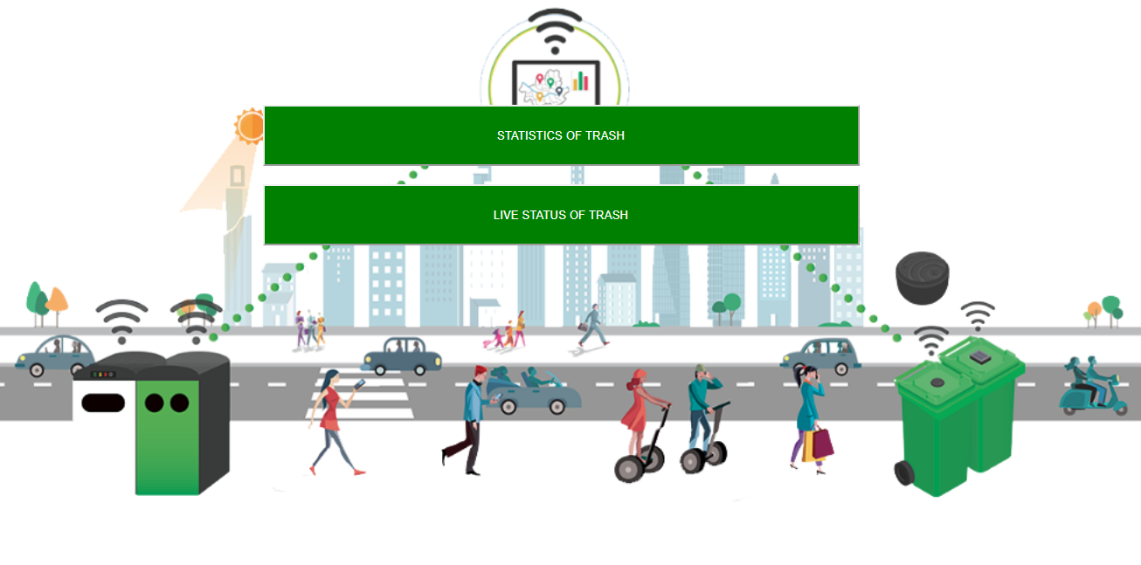

To be continue and see page # 35

Click this button and you can see the Live status of smart Dustbin

After clicking the statistics of trash, you will see the graphical representation of project that shows the vertical bar series, mark series, line series and pie chart of the trashcan.

This is Statistical view page

z

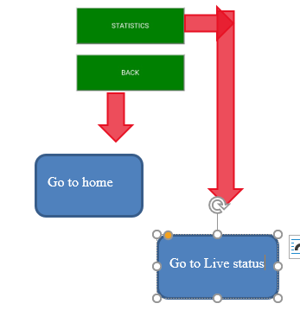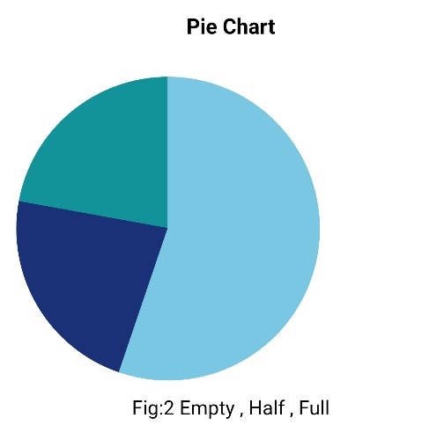

And the live status of trash shows the level of trashcan also shows the position of garbage in trashcan in three ways. The first way to show the Dustbin is empty, and the second way to show the Dustbin is half and the third way to show the Dustbin is full.

This is live status page and you can see the live status of Dustbin

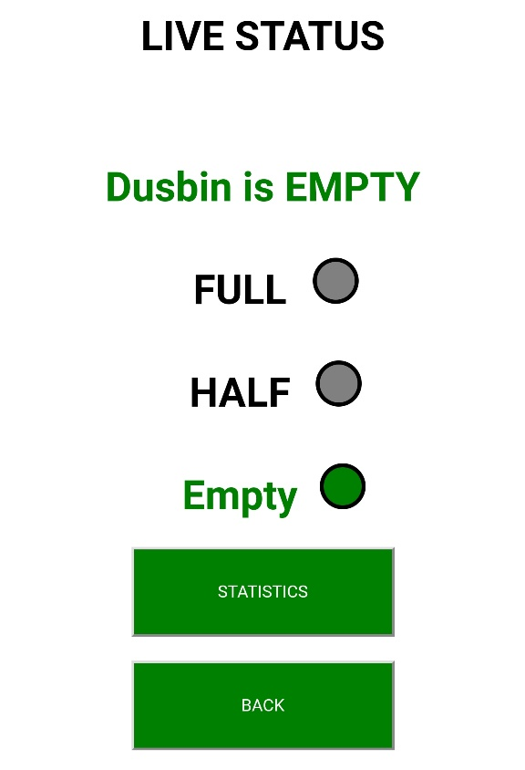

Go to statisitcs

Go to Live status

Go to statisitc

Go to home

Go to home

Go to home